Supplemental Information

Effect of endogenous FGF21 deficiency on the inflammatory microenvironment of the retina
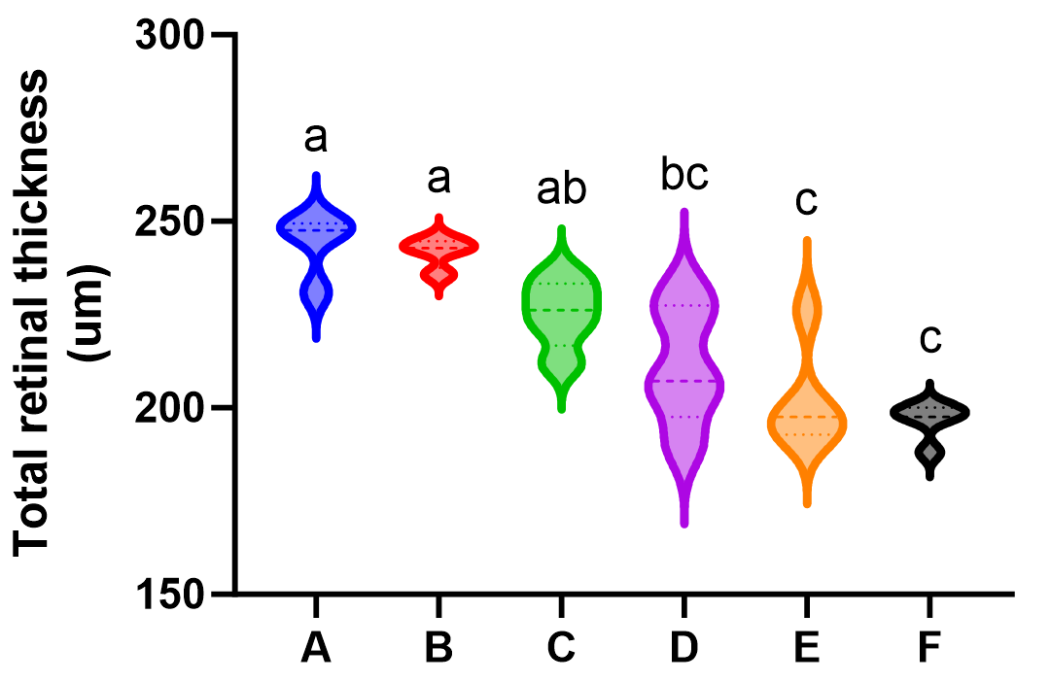
Supplementary Fig. 1 Total retinal thickness. A: WT mice; B: FGF21 KO mice; C: WT diabetic mice； D: FGF21 KO diabetic mice; E: WT AMD mice; F: FGF21 KO AMD mice. There were significant differences between groups with different letters (P<0.05, Tukey multiple comparison test). The same letter means no significant difference.

